# Arrays in c++ (Day 02):

1. Count even and odd numbers:

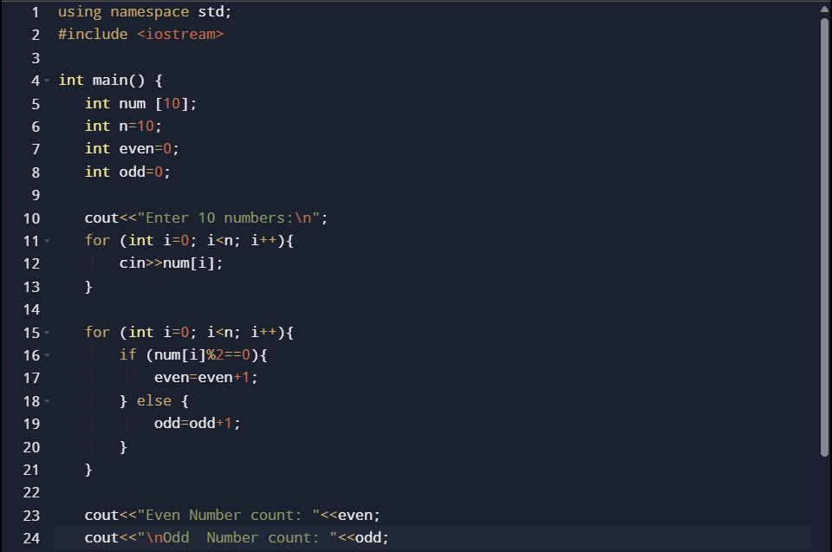

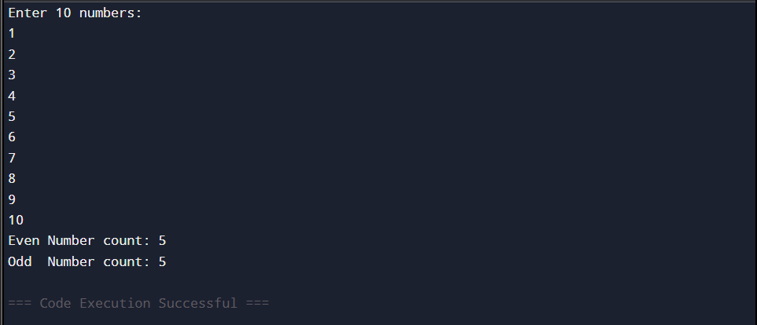

1. Count Positive, Negative & Zero Elements

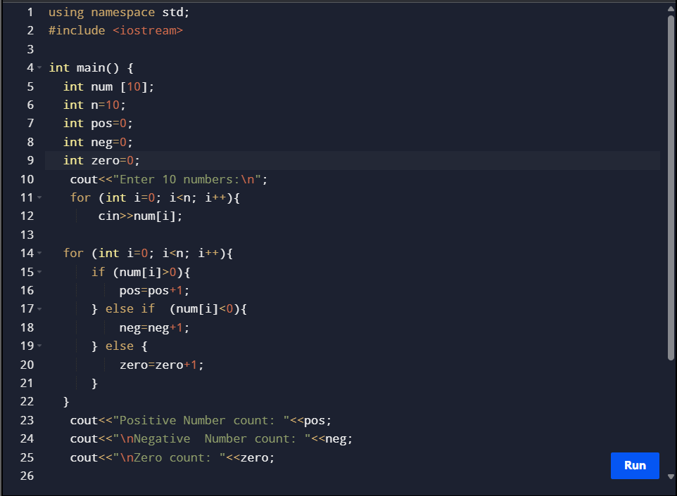

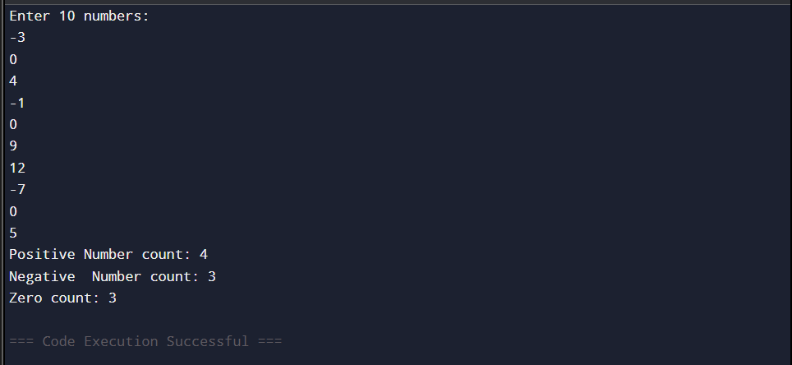

1. Used do while loop in array

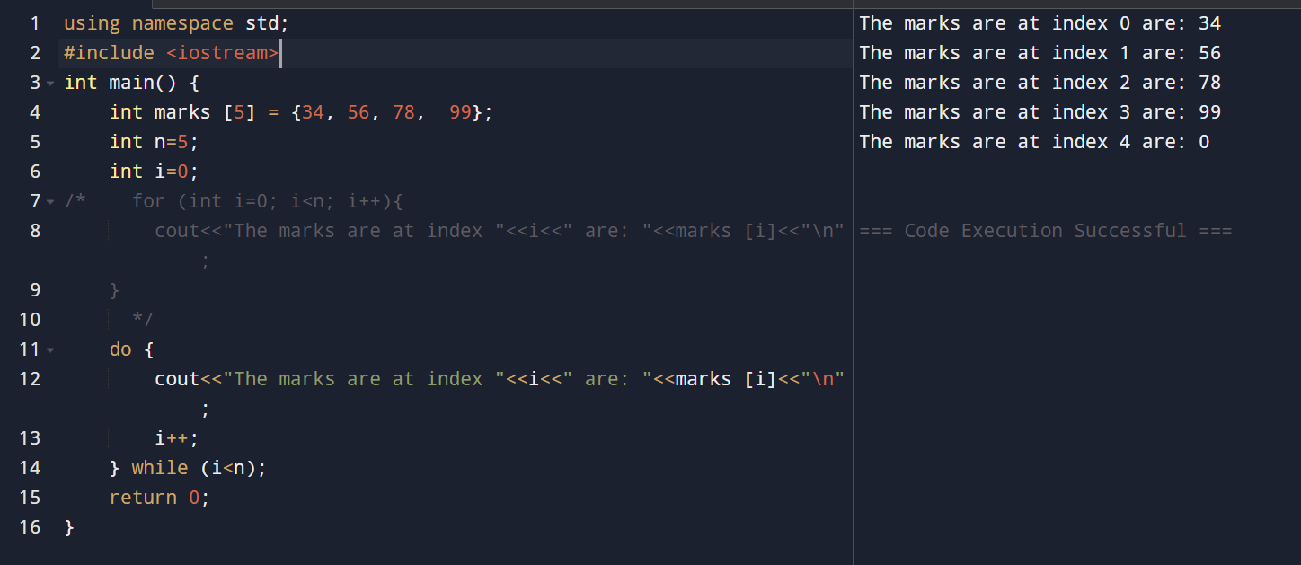

TASK (Beginner):



